8th Grade Core Classes Supply List

Necessary General Supplies

- Pencil Pouch- to carry pencils, pens, highlighters and other small supplies.
- Mechanical Pencils and extra lead
- Erasers
- If you choose to use regular pencils, also get a small pencil sharpener that catches the shavings.
- Colored Pencils
- Red pen
- Highlighter
- Extra folders for elective classes

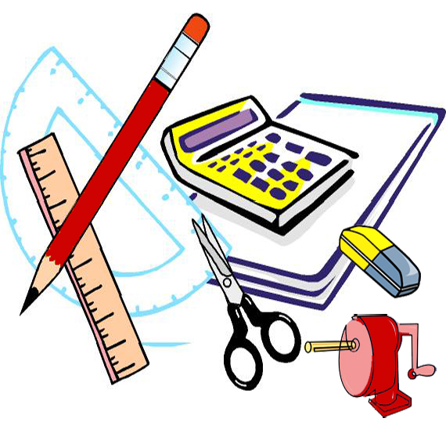Social Studies
- Duo tang folder with pockets and prongs
- Loose Leaf paper or spiral notebook

Math
- Duo tang folder with pockets and prongs
- 2 spiral notebooks
- Scientific Calculator

Science
- Duo tang folder with pockets and prongs
- 100 page Composition Book (lined or graph paper)
- Colored pencils (plan on using every day)

Language Arts
- Duo tang folder with pockets and prongs
- Loose Leaf paper or spiral notebook
- Personal mobile devices (iPads, Kindle Fire, smart phones, net books, tablets, etc.) may be used for certain projects in class with teacher and parent permission. A signed permission slip and waiver needs to be completed.

Recommended
- A dictionary to use at home (or a dictionary app on their mobile device)
- Ear buds or headphones to be kept in locker for computer lab use.
- Donations of Kleenex and hand sanitizer are GREATLY appreciated!!!

**We highly encourage students NOT to purchase large, cumbersome binders/ trapper keepers**

If you are unable to provide these supplies, please contact one of us and we will make arrangements for your child to have the essentials needed for school.

*Please check the Pierce Middle School website for any changes to this list.*

